**IP (JavaScript Lab):**

**Before starting this lab once go through examples uploaded on teacher’s data** (\\printsrv\Teacher Data\Aisha\IP\post mid\JavaScript\Examples from Lecture**) it contains all the examples we discussed in class.**

**Task 1:**

As we discussed in class, random number can be generated using Math.random() (by default between 0[inclusive] and 1[exclusive]) in javascript. A sample code snippet is given below:

|  |
| --- |
| <html>  <body>  <script>  var d = Math.random();  alert("random number = " + d);  </script>  </body>  </html> |

Create a page with one textbox and a button (As shown below). Also, write JavaScript code where the code generates a random integer between 1 to 10, we’ll call it **guess number**.

User can inputs a number in textbox. And clicks ‘*Check my Guess,* button. If the user input matches with the **guess number**, the program will display will show an alert with message "Good Work" otherwise shows "Not matched".

*Sample Screen* :

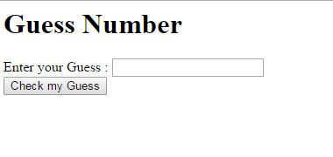

**Task 2:**

You can deal strings as arrays as well in JavaScript as shown below:

|  |
| --- |
| <html>  <head>  <script>  function showChars()  {  var str="abcde";  for (i = 0; i < 5; i++) {  alert(str[i]); }  }  </script>  </head>  <body>  <input type="button" value="Basic Loop Demo" onclick="showChars()"/>  </body>  </html> |

Create page that takes a string as input from user in textbox and on button click it checks if the string entered is palindrome or not.

*Sample Screen* :

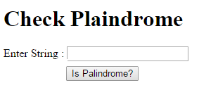

**Task 3:**

Write a JavaScript function that accepts a number as a parameter and check the number is prime or not. You can create interface of your choice.

**Task 4:**

Write a JavaScript program to construct the following pattern, using a nested for loop.

*

* *

* * *

* * * *

* * * * *

.

**Hint:**

* For this you have to write Script tag in body, NO buttons etc. are needed.
* To print on the page you can either use document.write() method OR innerHTML option of some tag as we discussed. Example of document.write() is given below.

|  |
| --- |
| <html>  <body>  <script>  document.write("Hello World!");  </script>  </body>  </html> |

Task 5:

Try the following code (you can see in array functions there is a **push** function. This function is used to aadd more values to an existing array, as you can see in example below.):

|  |
| --- |
| <html>  <body>  <p>Click the button to add a new element to the array.</p>  <button onclick="myFunction()">Try it</button>  <p id="demo"></p>  <script>  var fruits = ["Banana", "Orange", "Apple", "Mango"];  document.getElementById("demo").innerHTML = fruits;  function myFunction() {  fruits.push("Kiwi");  document.getElementById("demo").innerHTML = fruits;  }  </script>  </body>  </html> |

Now your task is as below:

Write a JavaScript program to add items in an blank array and display the items.

*Sample Screen* :   
